**POS Management**

**and Data Format**

KAI Unified Platform can include Point of Sale (POS) data in its reports, for comparison with Video Analytics data. There are 2 ways to import your POS data into your KAI Unified Platform account:

1. Automatically via FTP file upload

2. Manual insertion

p.2 p.7 p.6 p.8 p.9

Aggregation Using Labels

POS Data Integration

1. FTP or SFTP File Upload

2. Manual Insertion

POS Data Co-relation in People Counting Report

**Aggregation Using Labels**

A typical retail store has multiple cameras and multiple point of sale terminals. This data is more meaningful when aggregated for the whole store. KAI UP supports aggregation of video analysis data from multiple cameras of a store. This can be done using the Label Management module. Aggregated sales data can be viewed with the aggregated video analytics data, for better co-relation.

For example, consider a retail chain called “Alpha Retail”, which has 2 retail shops called “City Hall” and “Downtown”. Each shop has 2 KAI Nodes. In the customer account there would be total 4 nodes, perhaps named “CH Floor 1”, “CH Floor 2”, “DT East” and “DT West”. “CH Floor 1” and “CH Floor 2” can be labelled together under the name “City Hall”; “DT East” and “DT West” can be labelled together under the name “Downtown” (Figure 1).

Alpha Retail

City Hall Down Town

CH Floor 1 CH Floor 1 DT East DT West

Figure 1. The example of label system structure.

**User Guide for Importing POS Data** vaaas.kaisquare.com

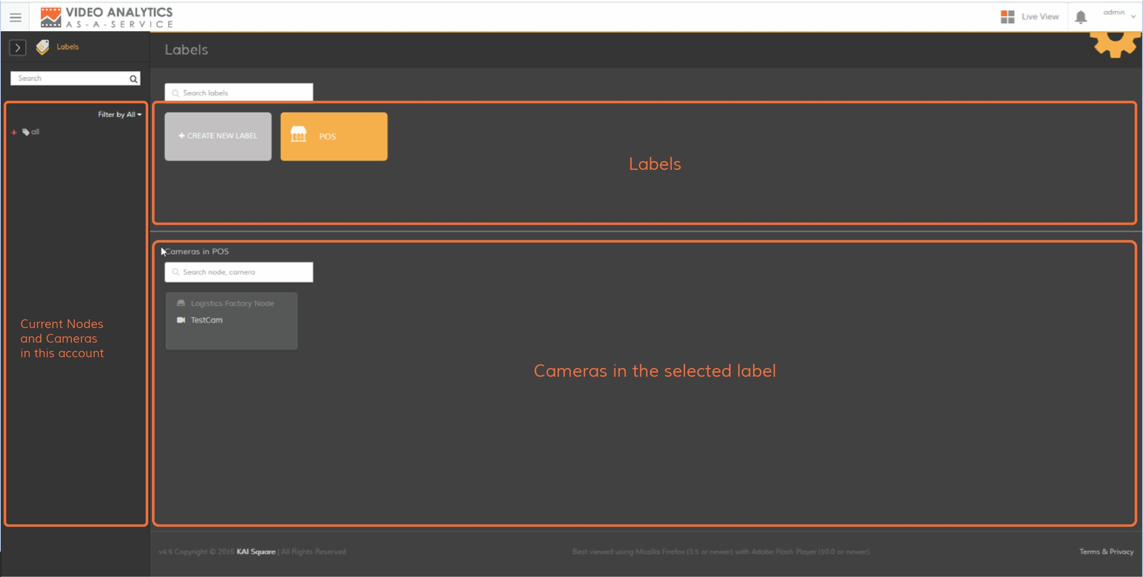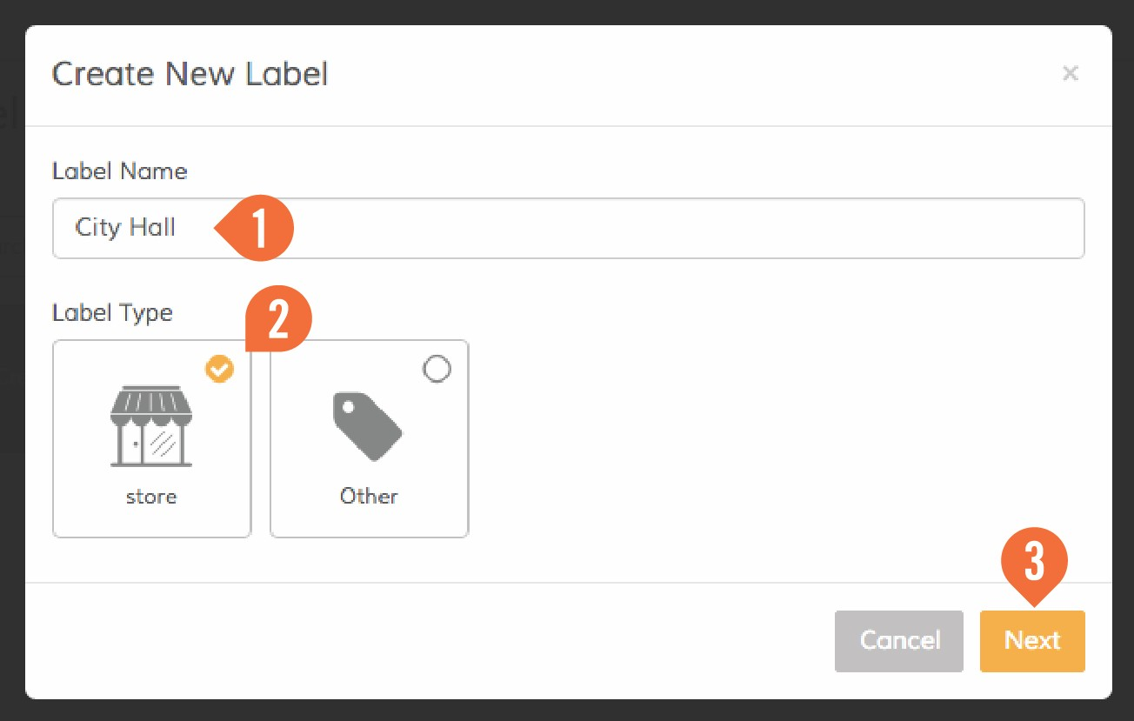

To do this, go to Label Management and follow the on-screen instructions or the screenshots below.

**step1** Go to Label Management.

Down Town

**step2** Create new label and click next

**3**

**Aggregation Using Labels**

**step3** Fill details and save

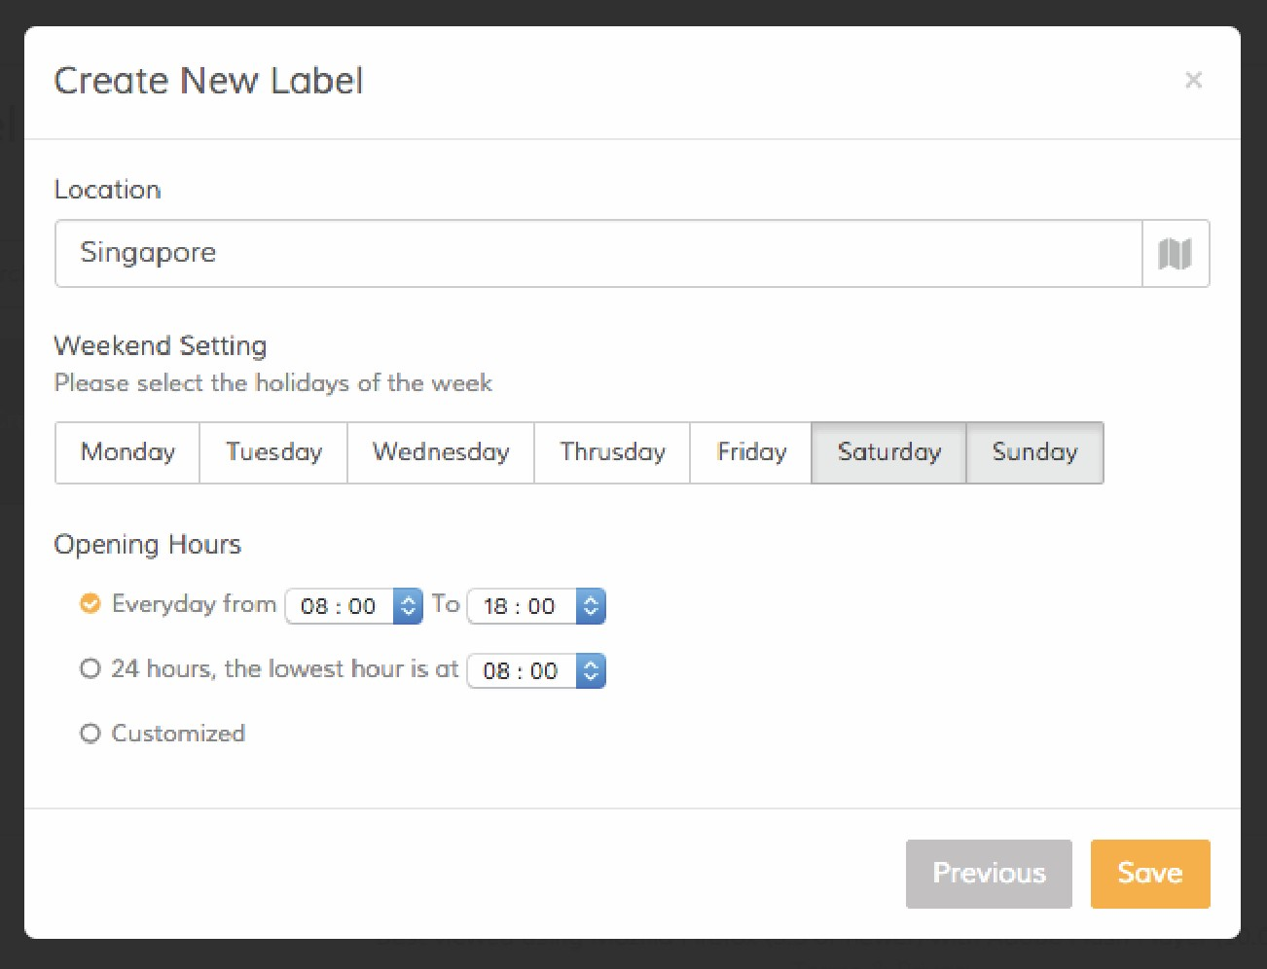

**step4** Assign Node or Camera to a Label by dropping on the desired Label

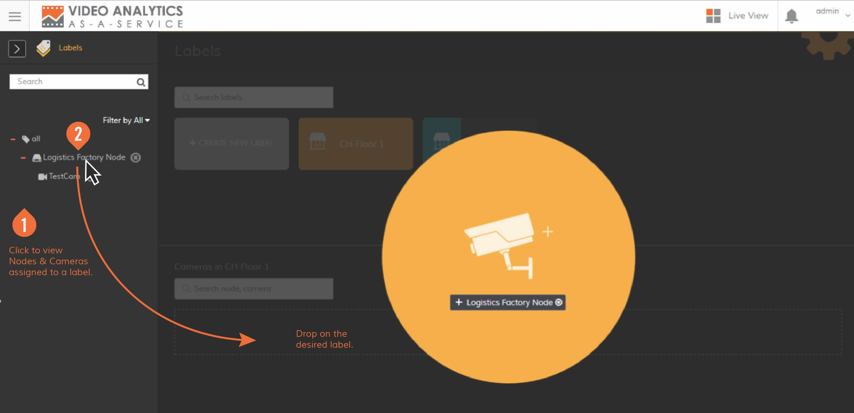

City Hall

**step5** Label set up complete

City Hall

P6

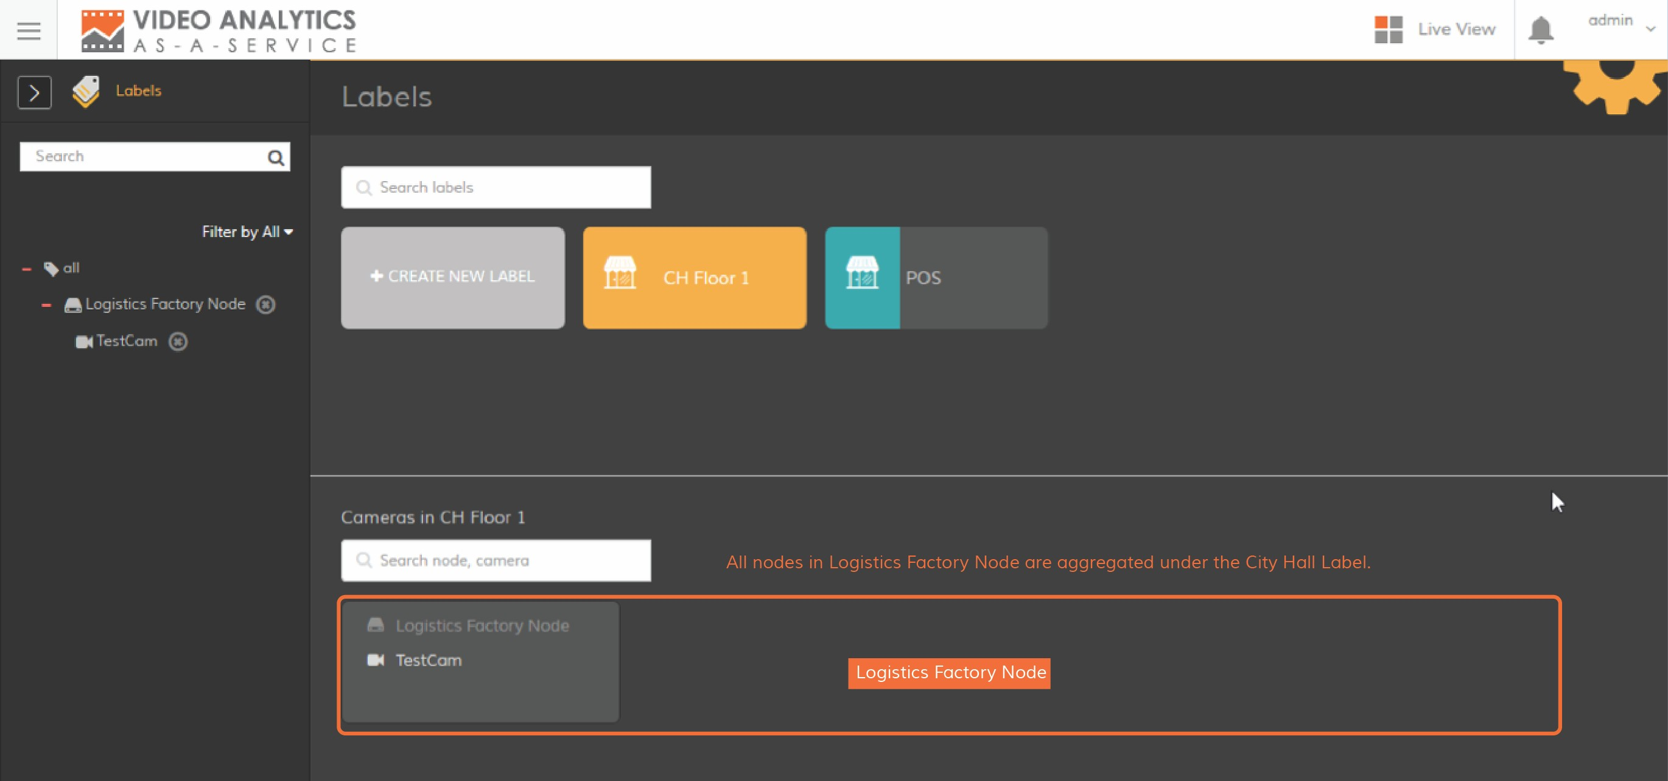

Down Town

City Hall

**step6** Go to People Counting, labels can be selected as data sources for generating aggregated reports

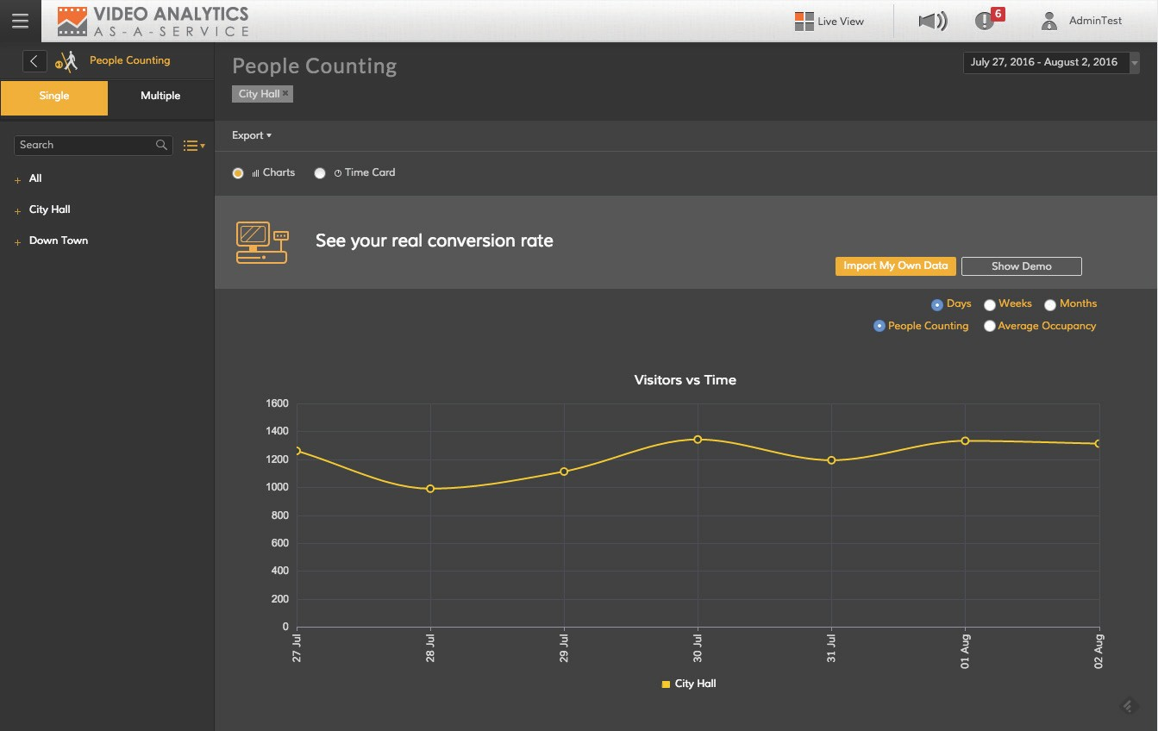

**POS Data Integration**

1. FTP or SFTP File Upload

**File Naming Convention**

Continuing with the above example, the aggregated POS data for City Hall retail shop should be in a file named

“City Hall.csv”. KAI UP will automatically co-relate the data by comparing POS data file name with the label name.

**Data Format**

Data must be in Semi-colon Separated Values (SSV) format, which is like the commonly used CSV format, but uses semi-colon as the field delimiter.

It should have the following columns:

**/ Date** (yyyy-mm-dd)

**/ Time** (hh:mm - hh:mm)

**/ Receipt Count** (a numeric value or empty if no data, commas are allowed, leading/trailing spaces are ignored)

**/ Sales Amount** (a numeric value or empty if no data, commas are allowed, dot is allowed for decimal

point, leading/trailing spaces are ignored)

Each row should be consolidated sales data of 1 hour, in multiples of 1 hour. The following are valid:

**/ 10:01 - 11:00**

**/ 16:01 - 18:00**

**/ 00:00 - 09:00**

Example rows

**/ 2014-06-11;10:01 - 11:00;31 ;25943.80**

**/ 2014-06-11;00:00 - 08:00;;**

**/ 2014-06-11;20:01 - 21:00;98 ;227,937.75**

Sample file

**/** [**City Hall. csv download**](https://www.evernote.com/shard/s67/sh/2ae81235-6c66-4a70-b14e-1bc3c25c86c5/8d56eb358d66d4b9fad3014e2b4c160c/res/b93f83e8-d0c6-4553-a501-148de70a6449/City%20Hall.csv)

**Configuration of Automatic FTP Download**

To set up automatic integration between your POS data and KAI UP, place your POS data file(s) on an FTP or SFTP Server and then configure your KAI UP account to download and import this data periodically.

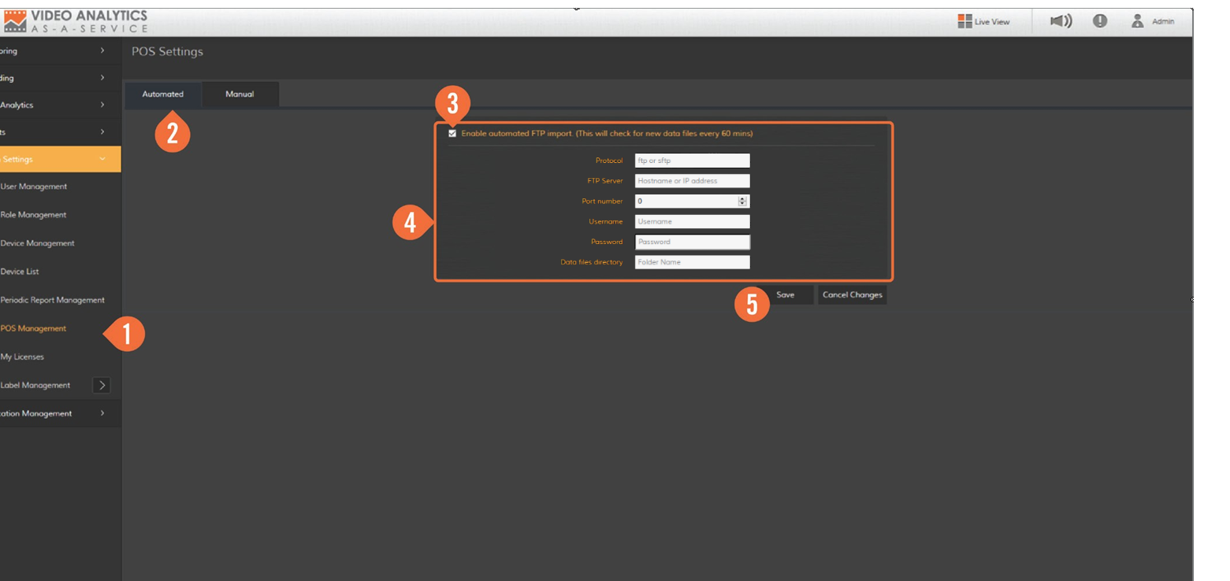

**/ Protocol**

Type in the customer’s server protocol e.g. ftp or sftp

**/ FTP Server**

Type in the customer’s FTP or SFTP server hostname e.g. ftp.alpharetail.com

**/ Port Number**

The FTP or SFTP server port number

**/ Username**

The username to be used for logging in to customer’s FTP or SFTP server

**/ Password**

The password to be used for logging in to customer’s FTP or SFTP server

**/ Folder Name**

The location on FTP or SFTP server where the POS data files are stored e.g. “/export/kaiup”

2. Manual Insertion

If you prefer to insert the POS data manually into KAI UP, go to “POS Management” module of your KAI UP

account and follow the screenshots below.

15/09/2016 15/09/2016

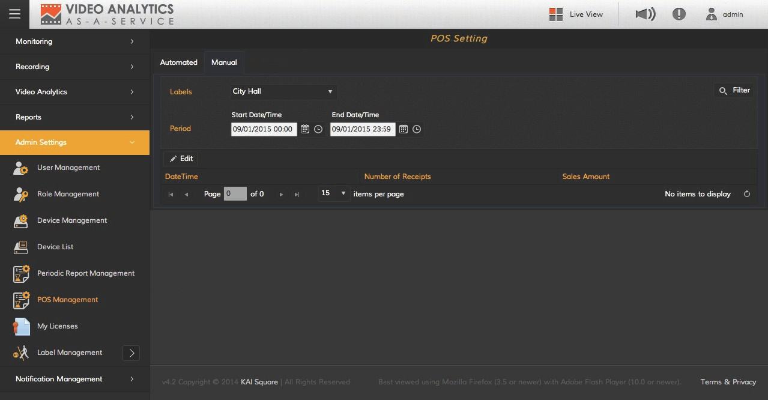

*Then click Save*

15/09/2016

15/09/2016

15/09/2016

15/09/2016

15/09/2016

15/09/2016

15/09/2016

15/09/2016

15/09/2016

15/09/2016

15/09/2016

15/09/2016

15/09/2016

15/09/2016

15/09/2016

*Input data here*

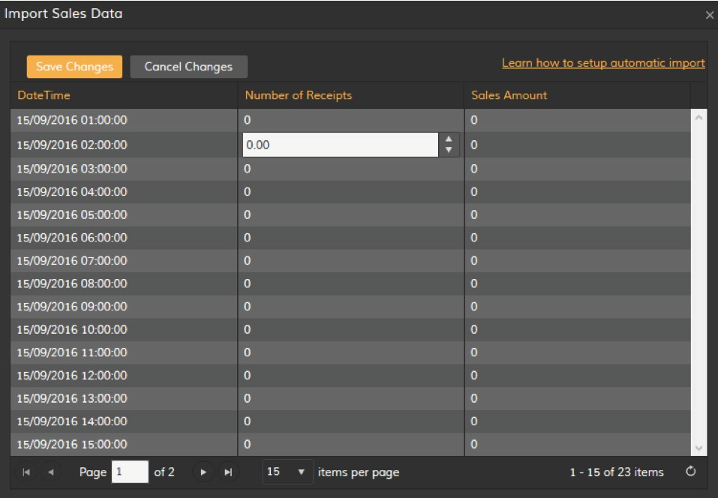

**POS Data Co-relation in People Counting Report**

Once your account has POS data, the People Counting report will display the conversion ratio.

City Hall

Down Town

City Hall

